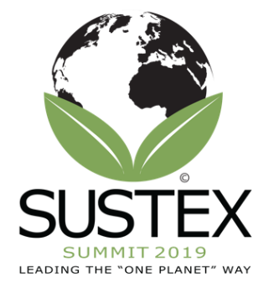
Agenda (Subject to Change) for Thursday, March 21st
8:30-9:00: Check-in, Coffee, and Pastries (Warrior Hall outside the Yowell Conference Center)
9:05-9:15: Opening Remarks by Lucas Loafman, J.D., Conference Chair and Interim Dean of the College of Business Administration at Texas A&M University-Central Texas (Yowell Conference Center)
9:15-9:25: Introduction to OPEN and the M.S. In One Planet Leadership by Dr. Jody Fry, Renowned Scholar and Coordinator of the M.S. In One Planet Leadership at Texas A&M University-Central Texas
9:25-10:25: Keynote #1 - Purpose, profit, people and planet: responsible business for the 21st century by Mr. Thomas Jelley, corporate vice president and former City of London corporate lawyer turned responsible business changer maker, now residing in Helsinki, Finland.
10:25-10:40: Morning Break – Refreshments in the hall outside of the Yowell Conference Center
10:40-12:10: Workshop – The Global Leader and Leadership Development for Sustainability by Dr. Jody Fry and Dr. Eleftheria (Ella) Egel, Independent Leadership Scholar and Management Consultant
12:10-1:10: Lunch on Campus (Bernie Beck Lecture Hall)
1:15-2:00: Keynote #2 by Dale Ross, Mayor of Georgetown, TX. Mayor Ross is known globally for the initiative In Georgetown to use only renewable energy, as well as other sustainability initiatives it’s pursuing.
2:05-2:50: Panel discussion on the issue of leadership for sustainability (Yowell Conference Center)
2:50-3:05: Afternoon Break - Refreshments in the hall outside of the Yowell Conference Center
3:05-4:05: Breakout Session – (Locations TBD)
- Workshop - Structured Open Space by Dr. Isabel Rimanoczy, Convener on LEAPI, the PRME Working Group on Sustainability Mindset
- Balancing Mission Readiness and the Environment by Michael Bush, Glenn Collier, and Timi Dutchuk with Fort Hood and CenTex Sustainable Communities Partnership by Kristina Ramirez with the city of Killeen, Christine Luciano with Fort Hood, and Jennifer Hetzel with the Greater Killeen Chamber of Commerce
4:10-4:45: Concluding Keynote by Tony Cooke, CEO of the One Planet Education Networks. Mr. Cooke resides in the United Kingdom. (Yowell Conference Center)
*Campus Tours available at 8:15, 12:40, and 5:00 – Meet in the entrance to Warrior Hall in front of the library.

