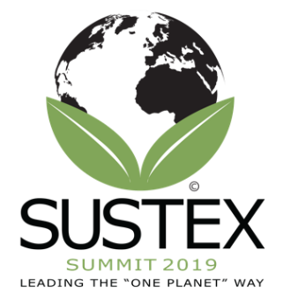
Agenda (Subject to Change) for Friday, March 22nd
8:20-8:40: Check-in, Coffee, and Pastries - Lobby outside the Yowell Conference Center
8:45-10:00: Paper Session #1 - Yowell Conference Center
- Yowell (A):
- The Impact of Examining the Sustainable Development Goals Through a New Lens by Jessica Ulman, Student at Unity College (20)
- A deep dive into the intersection of smart city technology, sustainability, and emergency management by Dr. Tammy Esteves, Troy University (20)
- Social Entrepreneurship: An applied model by Dr. Eleftheria (Ella) Egel, Independent Leadership Scholar and Management Consultant (30)
- Yowell (B):
- Employee engagement and workplace sustainability and wellness by Dr. Thomas Macagno (30), Chatham University
- Utilizing psychological to mitigate the impact of compassion fatigue to promote sustainable business practices by Matthew Temple, PhD student at Indiana Wesleyan (20)
- Connective Sustainability: Educating Global Leaders by David Fields, PhD student at Indiana Wesleyan (25)
10:00-10:15: Morning Break - Refreshments in the hall outside of the Yowell Conference Center
10:15-11:30: Workshop - Peer Learning: A Powerful Tool for Developing a Sustainable Mindset – Anywhere by Ernie Turner, President and Founder of Leadership in Motion - https://www.limglobal.net/ in Yowell Conference Center (A)
11:30-12:15: Lunch on Campus in Founders Hall – Bernie Beck Lecture Hall
12:20-1:20: Workshop - Altruism: A Common Thread Connecting Values, Spirituality, Leadership and Sustainability by Dr. Timothy Ewest, Houston Baptist University, Sharlene Buszka, Daemen College, and Dr. Michael Kraten, Houston Baptist University in Yowell Conference Center (A)
1:25-2:30: Paper Session #2
- Yowell (A):
- Teaching with Sustainable Development Goals An ‘emergent agenda of transformation’ by Dr. Janis Balda, Unity College (30)
- The Whole Institution Approach to ESD in Higher Education: Rationales, Dimensions, and Strategies by Dr. Liuang Liu, Central University of Finance and Economics (Beijing, China)
- Yowell (B):
- Supporting Entrepreneurial Ventures in Emerging Nations through Prosocial Crowdfunding by Dr. Vivien Jancenelle, Texas A&M University-Central Texas (35)
- Sustainability in bioenergy industry by Dr. Iddrisu Awudu, Quinnipiac University and Dr. Vinay Gonela, Texas A&M University-Central Texas (30)
2:35-3:35: Workshop - Powerful and easy: Develop a mindset for sustainability by Dr. Isabel Rimanoczy, Convener on LEAPI, the PRME Working Group on Sustainability Mindset, Dr. Abigail Schneider, Regis University, Dr. Richard Peregoy, University of Dallas, and Dr. Timothy Ewest, Houston Baptist.

